* **5 points -** Paste your results below the following sample, after entering the controller, method, your name and the number 10.
  + **Sample Results:**
* 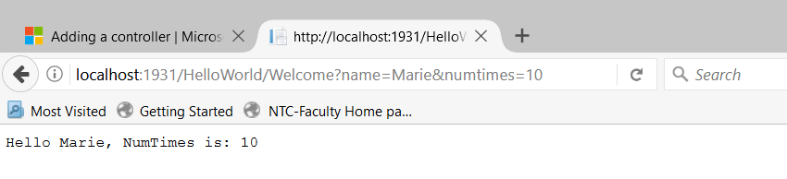
* **Paste your test results below, entering your name and the number 10 as query strings. Make sure your display shows the entire URL, showing the controller, method and your parameters entered.**
* 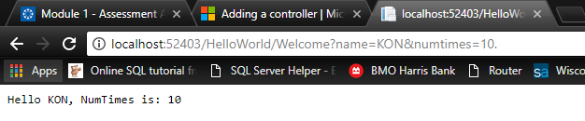
* Make the next changes in the tutorial using parameters
* Test your changes with the new parameters:
* Tutorial Results: 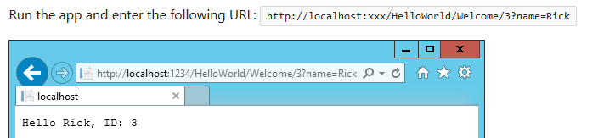
* **5 points** - Paste your results below the following sample, after entering the controller, method, your name and the number 10
  + **Sample Results**:
  + 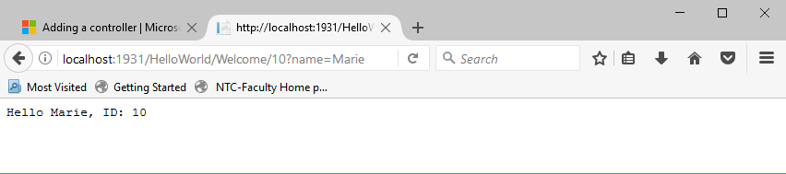
* 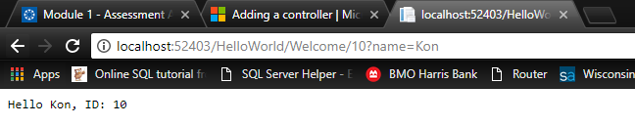**Paste your test results below, using your name and the number 10. Make sure your display shows the entire URL, showing the controller, method and both of your parameters entered:**
* This ends the “Adding a Controller” tutorial.
* Submit this updated word document, along with your xxxx.zip file for grading